**Assignment -3**

**Build CNN Model for Classification Of Flowers**

|  |  |
| --- | --- |
| **ASSIGNMENT DATE** | 10 October 2022 |
| **STUDENT NAME** | Boomika.K |
| **STUDENT ROLLNUMBER** | 813119104005 |
| **MAXIMUM MARKS** | 2 Marks |

**Question-1:**

* Download the Dataset

**SOLUTION:**

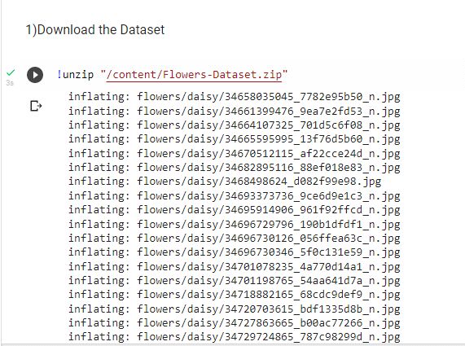

**Question-2:**

* Image Augmentation

**SOLUTION:**

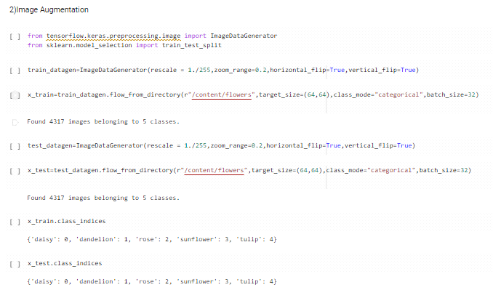

**Question-3:**

* Create Model & Add Layers

**SOLUTION:**

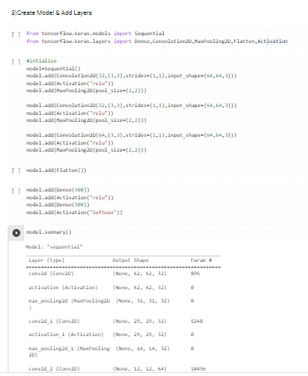

**Question-4:**

* Compile The Model

**SOLUTION:**

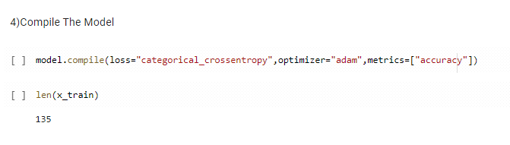

**Question-5:**

* Fit The Model

**SOLUTION:**



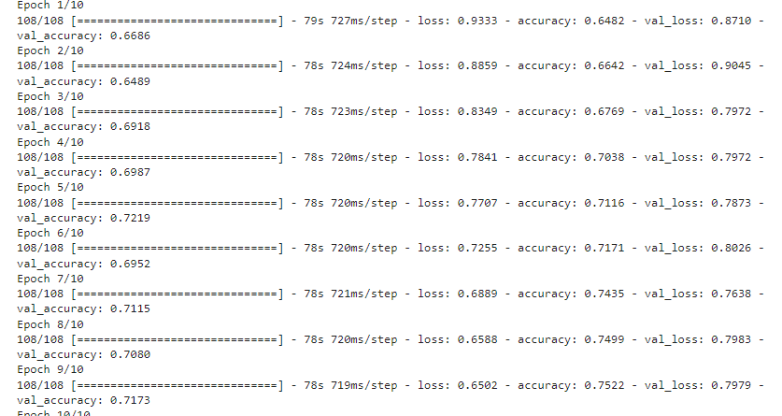

**Question-6:**

* Save The Model

**SOLUTION:**

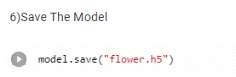

**Question-7:**

* Test The Model

**SOLUTION:**

